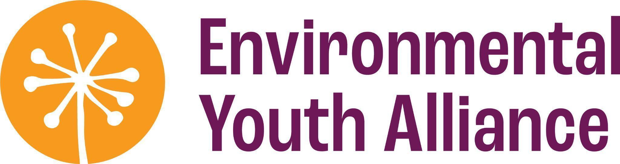

**Job Opportunity   
Job Title:** Manager, Fundraising & Communications  
**Terms:** 36 hrs/wk, full-time permanent

**Salary**: $54,288 - $58,032 ($29-31/hr)

**Benefits**: 5 weeks vacation | Extended Health Benefits | 5 days paid Professional Development

**Start Date:** June 3, 2024

Are you a skilled fundraiser inspired by land-based education and equitable access to nature? Do you want to play a role in the continued growth of our organization and youth programs? We’re looking for someone to lead our fundraising, communications, events, and outreach to help sustain and grow our land-based programs for youth from equity-denied communities in East Vancouver through digital content development, donor stewardship, grant writing, and public engagement.  **Responsibilities**

* Write & manage compelling grant applications to support EYA’s youth programs
* Research new funding opportunities
* Help to coordinate our annual spring fundraiser selling youth-grown native plants
* Lead the delivery of annual winter fundraising campaign
* Develop and implement strategies to grow our base of monthly supporters
* Support individual donor stewardship, including garden tours and thank you cards
* Steward existing business relationships, including garden visits and pop-up plant sales
* Help to increase donations from values-aligned local businesses
* Build EYA’s audience through community engagement (e.g. tabling at events)
* Coordinate digital content creation by fundraising & communications coordinator
* Supervise coordination and planning of public workshops
* Support donor and community engagement at EYA’s Annual General Meeting in July
* Lead implementation of decolonial and anti-oppressive fundraising practices
* Manage fundraising communications & data using Keela (CRM)
* Manage digital projects such as website maintenance and Google Ad Grants
* Prepare fundraising reports and metrics for Management Team and Board updates
* Supervise F&C coordinator as well as contractors and volunteers as needed
* Support administrative tasks related to marketing and communications

**Requirements**

* 2+ years of experience with marketing and communications
* Experience with grant writing, or strong writer and highly motivated to learn
* Knowledge of individual and corporate fundraising, or motivated to learn
* Experience developing and managing grants or willingness to learn
* Strong verbal and interpersonal skills
* Able to write clearly, concisely, and use anti-oppressive language
* Creative with a good eye for aesthetics and design
* Highly organized; great attention to detail
* Able to coordinate small events (10-50 attendees) and manage logistics
* Able to plan and prioritize work and meet deadlines
* Able to supervise staff and work collaboratively with a small team
* Committed to doing your best work
* Personal values fit with EYA mission and culture

**Assets**

* Experience with donor management systems
* Knowledge of video/digital marketing
* Class 5 or 7 driver’s license or plans to obtain one - most work happens remotely or at the EYA office, but some travel (across Vancouver and the Lower Mainland) will be required for meetings and events.

Don’t meet every requirement? We encourage you to apply even if your past experience doesn’t align perfectly. EYA honours lived experience and welcomes diverse ways of knowing.

**Prioritizing applicants from** **equity-denied communities**  
To ensure that our team represents the youth in our programs, EYA prioritizes applications from people who identify as Indigenous, Black, People of Colour, 2SLGBTQIA+, living with a disability, and folks from other equity-denied communities. We encourage you to self-identify in your application. Your application will only be shared with the hiring team.

To support employees from equity-denied communities, EYA provides extra paid personal days, Indigenous Peoples’ Day as a paid holiday, paid staff socials to connect with coworkers, frequent check-ins, and other supports as needed.

**About the organization**EYA empowers youth from equity-denied communities to become environmental stewards. We provide land-based education and paid job training programs that integrate Western and Indigenous perspectives on land stewardship. Our work recognizes the intersection of social and environmental injustice. You'll be joining a collaborative team of caring, creative, fun, like-minded colleagues and an organization committed to decolonizing action. Find out more about [our team](https://eya.ca/our-team/) and [work](https://eya.ca/our-mission/).

EYA operates on the unceded, shared territory of the xʷməθkʷəy̓əm (Musqueam), səlilwətaɬ (Tsleil-Waututh), and Sḵwx̱wú7mesh (Squamish) Nations, also known as Vancouver. [Read our land honouring](https://eya.ca/land-honouring/).

**Working environment**The Manager, Fundraising & Communications will be supported by the Co-Executive Director, Fundraising & Operations and will supervise the Coordinator, Fundraising & Communications. They will interact with youth participants, donors, and other supporters. The position is mostly home-based with access to EYA’s office in Chinatown, and periodic visits to programming sites and community events for donor engagement. Flexible Monday to Friday schedule with occasional weekend / evening work.

**How to apply**E-mail a resume and cover letter addressed to Carmen Wong, Co-Executive Director, Fundraising & Operations to [jobs@eya.ca](mailto:jobs@eya.ca) with “Fundraising & Communications Manager Application” in the subject line. Your cover letter will not be assessed as a writing sample. We really just want to get to know you, how your experience aligns with the role, and why you’re excited to apply. More casual written submissions are welcomed, or video/audio submissions if that is more comfortable for you.

The deadline to apply is **Sunday, May 12, 2024 or until filled.**

Applications will be reviewed upon submission and interviews will be scheduled during the week of May 13th. We will respond to all candidates who apply, whether shortlisted or not. If you are shortlisted, you will be invited to a 1-1.5 hour Zoom interview with two EYA employees and asked to provide samples of written and/or digital content. You will be provided with interview questions in advance and will be compensated $50 following completion of the interview.